Detection of eyes, nose and mouth in an image using inbuilt Matlab functions

* Algorithm depends upon the viola jones face, eyes, nose and mouth detectors.

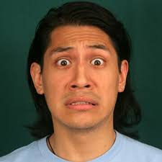

**Figure 1 Input image**

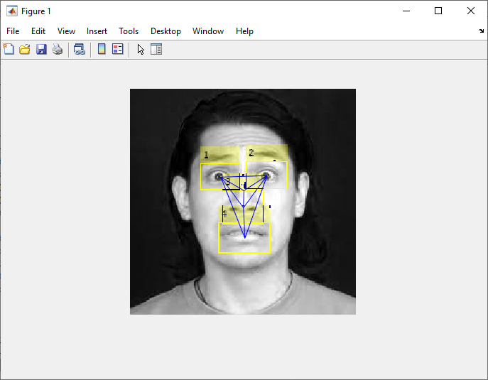

**Figure 2 Output image**

* The algorithm is checked for new born baby images.
* Algorithm works efficiently only on few images here are the examples

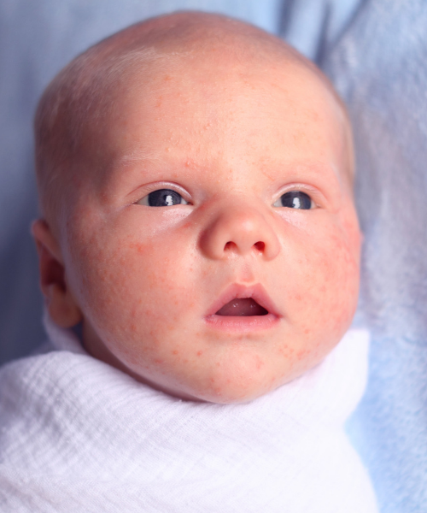

**Figure 3 Input image**

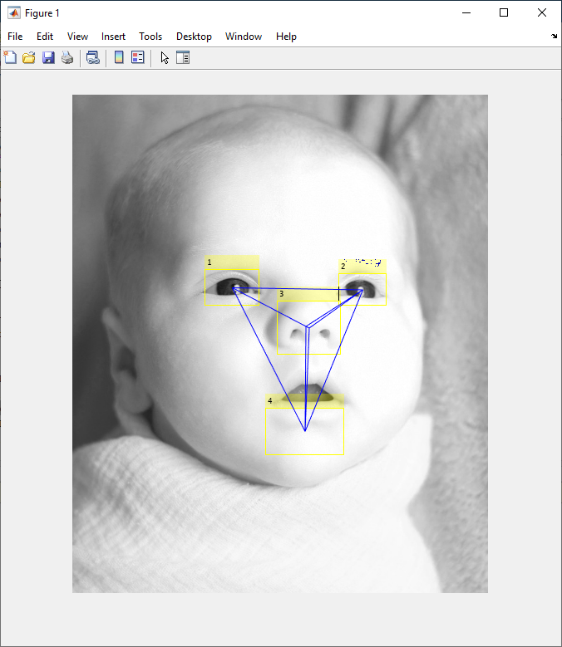

**Figure 4 Output image**

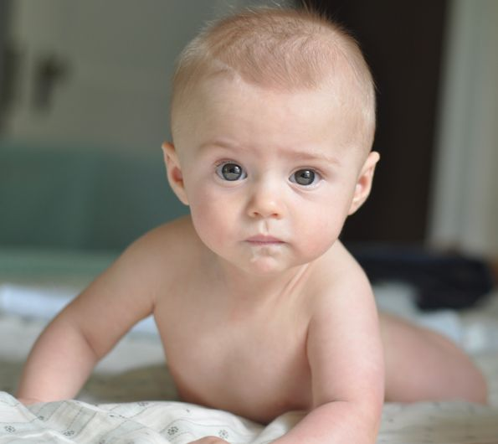 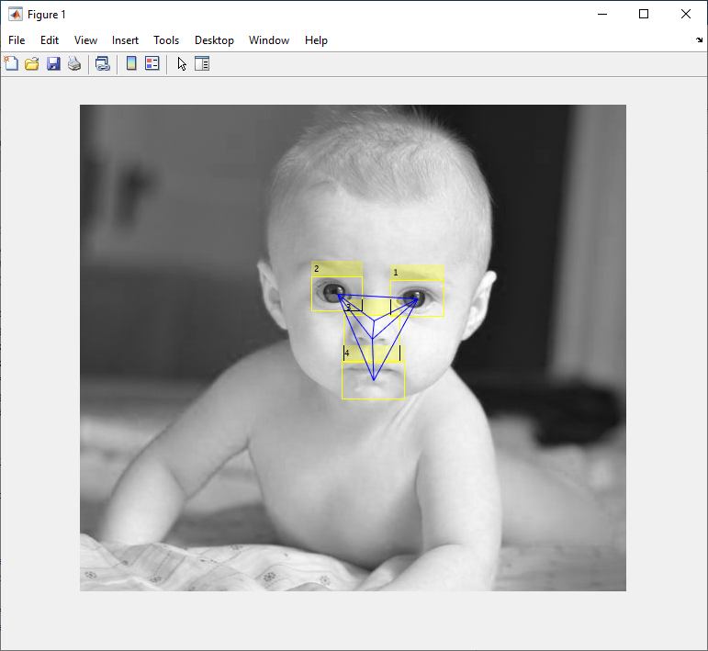

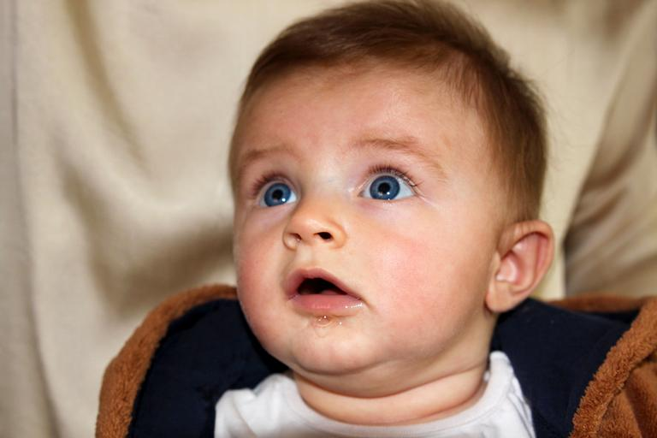 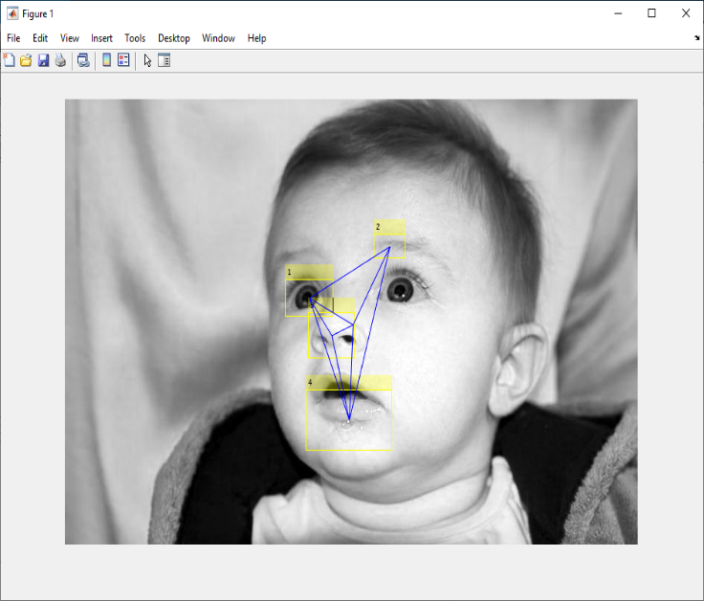

* Algorithm also fails to detect few faces as shown below

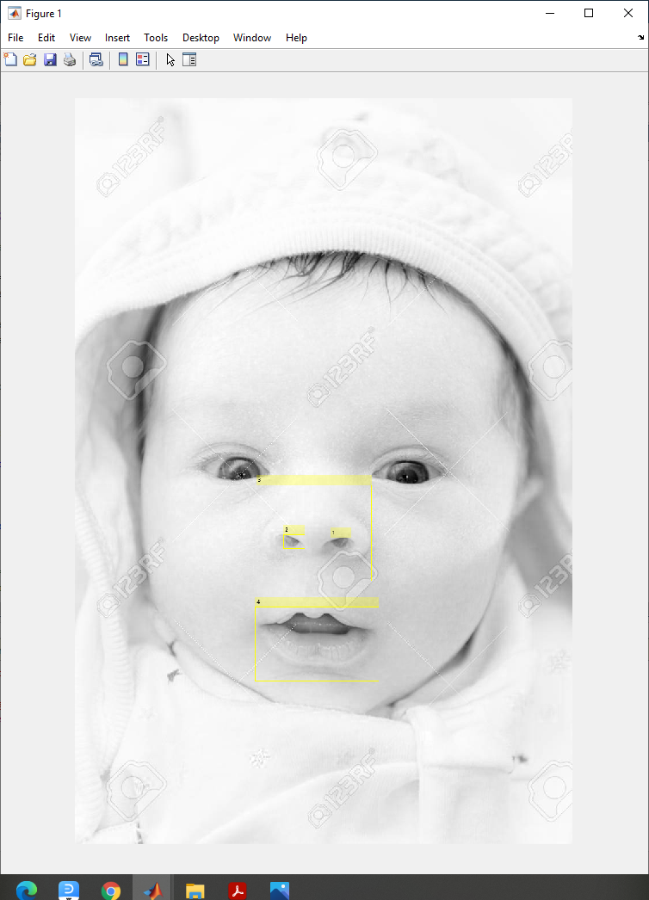

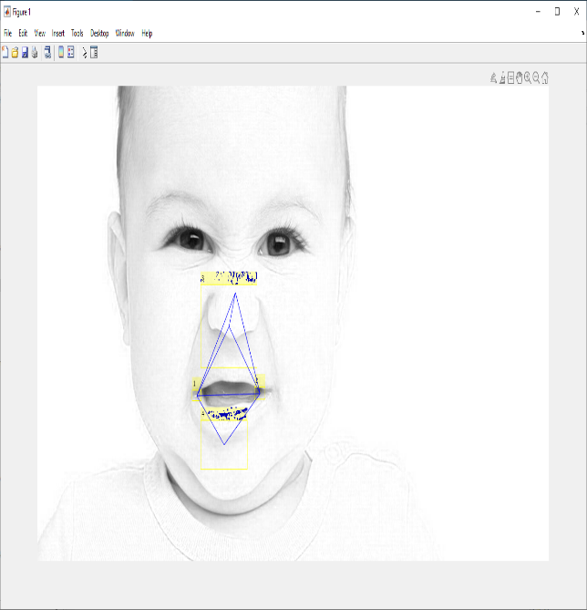 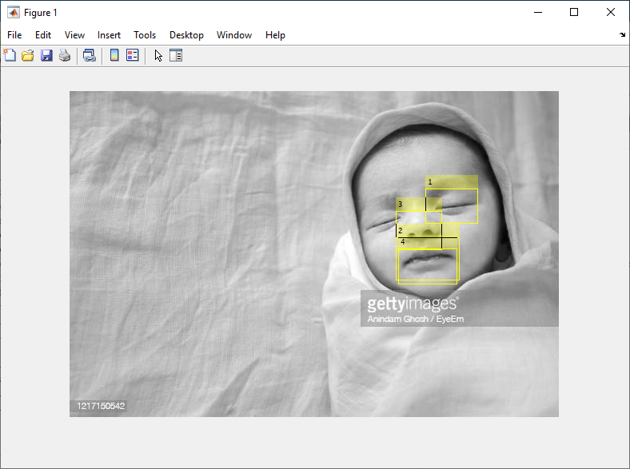

* Images from available recorded videos also does not get detected.

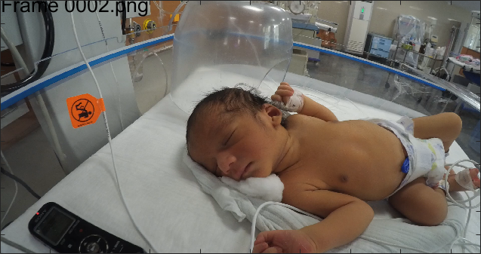

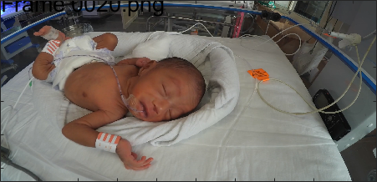

* Algorithm works only for few images with specific head positions.
* The position of the cameras is disturbed during the video recording, we have no proper image of the baby, hence this algorithm fails to detect baby face.
* Cameras position should be checked and properly placed in future recordings.
* Other algorithms need to be evaluated for available baby images.